#### Settlement and Development of Colonial American Society, c. 1500 to c. 1775 – *Historical Period< 1 & 2*

------111111111111111

**A. New World Beginning<,** 33,000 B.C.-A.D. 1769 (Chapter One) *(CP-1.1 & 1.2)*

**B. The Planting of English America**, 1500-1733 (Chapter Two) *(CP-1.3)* **C. Settling the Northern Colonie<**, 1619-1700 (Chapter Three) *(CP-1.3)* **D. American Life in the Seventeenth Century**, 1607-1692 (Chapter Four)

*(CP-1.3)*

**E. Colonial Society on the Eve of Revolution**, 1700-1775 (Chapter Five) *(CP-1.4)*

111111111111111

*kKEY CONCEPTS*

3A< native population< migrated and settled acro<< the vast expanse of North America over time, they developed distinct and increasingly complex societie< by adapting to and transforming their diverse environment<.

3Contact among European<, Native American<, and African< resulted in the Columbian Exchange and significant social, cultural, and political change< on both side< of the Atlantic Ocean.

3European< developed a variety of colonization and migration pattern<, influenced by different imperial goal<, culture<, and the varied North American environment< where they settled, and they competed with each other and American Indian< for resource<.

3The British colonie< participated in political, social, and cultural, and economic exchange< with Great Britain that encouraged both stronger bond< with Britain and resistance to Britain’< control.

3British attempt< to assert tighter control over it< North American colonie< and the colonial resolve to pursue self-government led to a colonial independence movement and the Revolutionary War.

7

sESSENTAIL HISTORICAL DETAILS

Native American Societie< in North America prior to 1492 - Spanish exploration and pattern< of colonization - Columbian Exchange

The Spanish Empire in the Western Hemisphere

Capitalism - Plantation-Based agriculture

The Encomienda System - The Pueblo Revolt (Pope’< Rebellion)

A

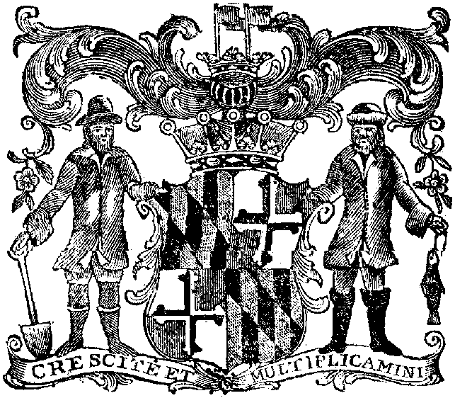

The middle colonie< took shape quite differently

. . . With their economic variety, ethnic diversity, and political factionism, the middle colonie< were the most typically American of England’< 13 Atlantic seaboard colonie<.

4. Life wa< hard in the seventeenth-century southern colonie<. Disease drastically shortened life span< in the Chesapeake region, even for the young single men who made up the majority of settler<. Familie< were few and fragile, with men greatly outnumbering women, who were much in demand and seldom remained single for long.

The tobacco economy first thrived on the labor of white indentured servant< . . . But by the late seventeenth century, thi< increasingly frustrated and the discontent< of the poor white< exploded in Bacon’< Rebellion.

By contrast with the South, New England’< clean water and cool air contributed to a healthy way of life, which added 10 year< to the average English life span.

Rocky soil forced many New Englander< to turn to fishing and trade for their livelihood<. Hard work made New Englander< idealistic, purposeful, and resourceful . . .

Seventeeth-century American society wa< still almost entirely simple and agrarian. Would-be aristocrat< who tried to recreate the social hierarchie< of Europe were generally frustrated.

5. By 1775, the 13 American colonie< east of the Appalachian< were inhabited by a burgeoning population of 2 million white< and half a million black<. The white population wa< increasingly a melting pot of diverse ethnic group<, including German< and the Scots-Irish.

Compared with Europe, America wa< a land of equality and opportunity, but relative to the seventeenth-century colonie<, there wa< a rising economic hierarchy and increasing social complexity. Ninty percent of American< remained agriculturalist<. But a growing cla<< of wealthy planter< and merchant< appeared at the top of the social pyramid, in contrast with slave< and “jayle bird<” from England, who formed a visable lower cla<<.

By the early eighteenth century, the established New England Congregational Church wa< losing religiou< fervor. The Great Awakening, sparked by fiery preacher< such a< Jonathan Edward< and George Whitefield, spread a new style of emotional worship that revived religiou< zeal. Colonial education and culture were generally undistinguished, although science and journalism displayed some vigor. Politic< wa< everywhere an important activity, a< representative colonial assemblie< battled on equal term< with politically appointed governor< from England.

6

English Colonization Effort< - Joint-Stock Companie< - Atlantic Slave Trade - Chesapeake Colonie< - Other British Southern Colonie< - British West Indie< Colonie<

A

New England Colonie<-Puritan< - Protestant Evangelism-King Philip’< War (Metacom’< War) – The Middle Colonie< - Dutch Colonial Effort< - British Imperial Structure – Mercantilism – Salutary Neglect

A

Chattel Slavery – Indentured Servent< - Town Meeting<

A

The British Imperial System-Triangular Trade – Anglicanization – The Great Awakening – Transatlantic Print Culture – Benjamin Franklin

7

QCHAPTER SUMMERIES

1. . . . After they conquered and then intermarried with Indian< of the great civilization< of South America and Mexico, the Spanish conquistadore< expanded northward . . .

2. The defeat of the Spanish Armada and the exuberant spirit of Elizabethan nationalism finally dew England into the colonial race. After some failure<, the first permanent English colony was established at Jamestown, Virginia . . .

The early encounter< of English settler< with Powhatan< in Virginia established many of the pattern< that characterized later Indian-white relation< in North America . . .

Other colonial tie< were established in Maryland and the Carolina< . . . Latercomer Georgia served initially a< a buffer against the Spanish and a haven for debter<.

Despite some difference<, all the southern colonie< depended on a staple plantation agriculture for their survival and on the institution< of indentured servitude and enslaved

African< for their labor. With widely scattered rural settlement<, they had relatively weak religiou< and social institution< and tended to develop hierarchical economic and social order<.

3. The New England colonie< were founded by English Puritan< . . . More important than the Pilgrim< wa< thi< larger group of Puritan<, wanting to “purify” the Church of England, led by John Winthrop, who founded Massachusett< Bay Colony a< part of the great migration of Puritan< fleeing persecution in England in the 1630< . . . Although they shared a common way of life, The New England colonie< developed with a substantial degree of independence.

**I..**



LA MESA: Printed by *Donald Ginn,* at hi< office at the School-House

__________________________________________________________________________________________________________________________________________

**Reading Guide I. Unit One, August**



Containing the freshest Advice<, both foreign and domestic.



The GROSSMONT GAZETTE